



**GROUP REPORT**



|  |  |
| --- | --- |
| Subject Name: | Enterprise Web Software Development |
| Subject Code: | COMP 1640 |
| Submission Date: | 19 April 2023 |
| Group: | 14 |

**Table of Contents**

1. Project Introduction. 5

1.1. Objective. 5

1.2. Group Members. 5

1.3. Development Tools. 6

1.3.1. Visual Studio. 6

1.3.2. GitHub. 7

1.3.3. Trello. 7

2. Database Design. 8

2.1. Entity Relationship Diagram (ERD). 8

2.2. Relational Schema. 9

3. Functionality Diagram. 9

3.1. Use Case. 9

3.1.1. Use Case - Admin. 10

3.1.2. Use Case - QA/QC Coordinator. 10

3.1.3. Use Case - Staff. 11

3.2. Activity Diagram. 11

3.2.1. Staff View Most Viewed Ideas. 11

3.2.2. Staff View Most Popular Ideas. 12

3.2.3. Staff Submit Idea. 12

3.2.4. Staff Edit Idea. 13

3.2.5. Staff Delete Idea. 13

3.2.6. Staff Post New Comment in Idea. 14

3.2.7. Staff Delete Comment in Idea. 14

3.3. Sitemap. 15

4. Project Design. 15

5. Project Test. 17

5.1. Testing Plan. 17

5.2. Test Log. 20

5.2.2. Test Log – Sprint 2. 21

5.2.3. Test Log – Sprint 3. 22

5.3. Test Data. 23

5.3.1. User Register. 24

5.3.2. Create Idea. 25

5.3. Testing Evidence. 25

6. Agile Method. 26

6.1. Product Backlogs. 26

6.2. Sprint Backlogs. 28

6.2.1. Sprint 1. 28

6.2.2. Sprint 2. 30

6.2.3. Sprint 3. 33

10. REFERENCES. 36

**Table of Figures**

[Figure 1. Development Tools - Visual Studio 6](https://d.docs.live.net/63943eb845c7cb0a/1640/1640%20Project.docx#_Toc131800206)

[Figure 2. Development Tools - GitHub 7](https://d.docs.live.net/63943eb845c7cb0a/1640/1640%20Project.docx#_Toc131800207)

[Figure 3. Development Tools - Trello 7](https://d.docs.live.net/63943eb845c7cb0a/1640/1640%20Project.docx#_Toc131800208)

[Figure 4. Database Design - Entity Relationship Diagram 8](https://d.docs.live.net/63943eb845c7cb0a/1640/1640%20Project.docx#_Toc131800209)

[Figure 5. Database Design - Relational Schema 9](https://d.docs.live.net/63943eb845c7cb0a/1640/1640%20Project.docx#_Toc131800210)

[Figure 6. Use Case for Admin 10](https://d.docs.live.net/63943eb845c7cb0a/1640/1640%20Project.docx#_Toc131800211)

[Figure 7. Use Case of QA/QC Coordinator 10](https://d.docs.live.net/63943eb845c7cb0a/1640/1640%20Project.docx#_Toc131800212)

[Figure 8. Use Case for Staff 11](https://d.docs.live.net/63943eb845c7cb0a/1640/1640%20Project.docx#_Toc131800213)

[Figure 9. Activity Diagram - Staff view most viewed Ideas 11](https://d.docs.live.net/63943eb845c7cb0a/1640/1640%20Project.docx#_Toc131800214)

[Figure 10. Activity Diagram - Staff view most popular Ideas 12](https://d.docs.live.net/63943eb845c7cb0a/1640/1640%20Project.docx#_Toc131800215)

[Figure 11. Activity Diagram - Staff submit idea 12](https://d.docs.live.net/63943eb845c7cb0a/1640/1640%20Project.docx#_Toc131800216)

[Figure 12. Activity Diagram - Staff edit idea 13](https://d.docs.live.net/63943eb845c7cb0a/1640/1640%20Project.docx#_Toc131800217)

[Figure 13. Activity Diagram - Staff delete Idea 13](https://d.docs.live.net/63943eb845c7cb0a/1640/1640%20Project.docx#_Toc131800218)

[Figure 14. Activity Diagram - Staff post new comment in Idea 14](https://d.docs.live.net/63943eb845c7cb0a/1640/1640%20Project.docx#_Toc131800219)

[Figure 15. Activity Diagram - Staff delete comment in Idea 14](https://d.docs.live.net/63943eb845c7cb0a/1640/1640%20Project.docx#_Toc131800220)

[Figure 16. Sitemap 15](https://d.docs.live.net/63943eb845c7cb0a/1640/1640%20Project.docx#_Toc131800221)

[Figure 17. Responsive bug on My Idea List 25](https://d.docs.live.net/63943eb845c7cb0a/1640/1640%20Project.docx#_Toc131800222)

[Figure 18. Fix responsive bug on My Idea List 26](https://d.docs.live.net/63943eb845c7cb0a/1640/1640%20Project.docx#_Toc131800223)

**List of Tables**

[Table 1. Group Members 6](https://d.docs.live.net/63943eb845c7cb0a/1640/1640%20Project.docx#_Toc131800255)

[Table 2. Testing Plan 21](https://d.docs.live.net/63943eb845c7cb0a/1640/1640%20Project.docx#_Toc131800256)

[Table 3. Test Log - Sprint 1 22](https://d.docs.live.net/63943eb845c7cb0a/1640/1640%20Project.docx#_Toc131800257)

[Table 4. Test Log - Sprint 2 23](https://d.docs.live.net/63943eb845c7cb0a/1640/1640%20Project.docx#_Toc131800258)

[Table 5. Test Log - Sprint 3 24](https://d.docs.live.net/63943eb845c7cb0a/1640/1640%20Project.docx#_Toc131800259)

[Table 6. Test Data – User Register 25](https://d.docs.live.net/63943eb845c7cb0a/1640/1640%20Project.docx#_Toc131800260)

[Table 7. Test Data - Create Idea 26](https://d.docs.live.net/63943eb845c7cb0a/1640/1640%20Project.docx#_Toc131800261)

[Table 8. Product Backlog 29](https://d.docs.live.net/63943eb845c7cb0a/1640/1640%20Project.docx#_Toc131800262)

[Table 9. Sprint Backlogs - Sprint 1 31](https://d.docs.live.net/63943eb845c7cb0a/1640/1640%20Project.docx#_Toc131800263)

[Table 10. Sprint Backlogs - Sprint 2 34](https://d.docs.live.net/63943eb845c7cb0a/1640/1640%20Project.docx#_Toc131800264)

[Table 11. Sprint Backlogs - Sprint 3 36](https://d.docs.live.net/63943eb845c7cb0a/1640/1640%20Project.docx#_Toc131800265)

## **1. Project Introduction.**

In the current digital age, that we are living in, the internet has, in a way, created a culture of instant gratification. Almost any activities and any questionnaires or doubts that we have can be promptly looked up, and it has made traditional forms of information exchange obsolete. This is why having an online platform dedicated to the university is vital. These online platforms will be tremendously helpful in extenuating circumstances where classes and lectures have to be conducted remotely for an extended period of time (Libre, 2021). Being away from the campus for a prolonged period can cause students, teachers, and staff to become disconnected from their peers. An online platform to promote communication and interaction among people in the university is exactly what we need to create a more engaging learning environment.

**1.1. Objective.**

For this report, we are presenting the role-based idea collection system that our team has developed. In this project, we are tasked to develop a website to gather ideas from people within a university. These ideas will help the staff in the university to be more informed of the areas that need to be amended, so as to create an environment more engaging and conducive to learning. The primary functions that will be in the system include staff can submit ideas, ideas can be tagged into categories, Quality Assurance Manager (QA Manager) can create or delete categories, and ideas can be commented on as well as giving reactions via the like or dislike button once for each idea.

**1.2. Group Members.**

Before diving into the heart of the report, let us introduce the members of the team. They are Dinh Thanh Luan, Tran Phan Phi Long, Le Khac Dang Khoa, Tran Tuan Vinh, and Tran Duy Quan. While Le Khac Dang Khoa and Tran Duy Quan are in charge of the system's front end, Dinh Thanh Luan, Tran Tuan Vinh, and Tran Phan Phi Long are taking roles as the system’s back end.

|  |  |  |
| --- | --- | --- |
| Member’s Name | Member’s Id | Member’s technical role |
| Le Khac Dang Khoa | GCS200265 | Front-end developers |
| Tran Duy Quan | GCS200392 | Front-end developers |
| Dinh Thanh Luan | GCS200115 | Back-end developers |
| Tran Tuan Vinh | GCS200282 | Back-end developers |
| Tran Phan Phi Long | GCS200214 | Back-end developers |

Table 1. Group Members

**1.3. Development Tools.**

#### **1.3.1. Visual Studio.**

The Visual Studio is a free integrated development environment (IDE) from Microsoft. It allows us edit, debug, and build code, then publish an app by providing the standard editor, debugger, compilers, code completion tools, graphical designers, and many other features to improve the process of software development. Visual Studio can be used for developing 36 programming languages and enables the code editor and debugger to support (to various degrees) almost all programming language as long as a language-specific tool is available. C, C++, C++/CLI, Visual Basic.NET, C#, F#, JavaScript, TypeScript, XML, XSLT, HTML, and CSS are among the built-in languages. Plug-ins provide support for additional languages such as Python, Ruby, Node.js, and M, among others.



Figure 1. Development Tools - Visual Studio

Our group has decided that the system will be written in language C# - one of the most popular programming languages for develop website, combines with the base of ASP.NET Core. Specifically, we are going to using the ASP.NET Core MVC Web App template on Visual Studio 2022.

#### **1.3.2. GitHub.**

GitHub is an Internet hosting service for software development and version control using Git.

It provides the distributed version control of Git plus access control, bug tracking, software feature requests, task management, continuous integration, and wikis for every project. The key feature of the GitHub we may use repositories, branches, commits, and pull/push request.



Figure 2. Development Tools - GitHub

All Git commands that we use in our project includes:

+ git clone: Clone a repository into a new directory.

+ git add: Add file contents to the index.

+ git commit -m “msg”: Record changes to the repository.

+ git push: Update remote refs along with associated objects.

#### **1.3.3. Trello.**

Trello is the visual tool that empowers my team to manage project by task tracking. With Trello, we can add files, checklists, burndown chart for every sprint if plug-in more function. Moreover, it can be modified by members at the same time, and we can do it at home, which is help us follows closely about the process of project.



Figure 3. Development Tools - Trello

## **2. Database Design.**

**2.1. Entity Relationship Diagram (ERD).**

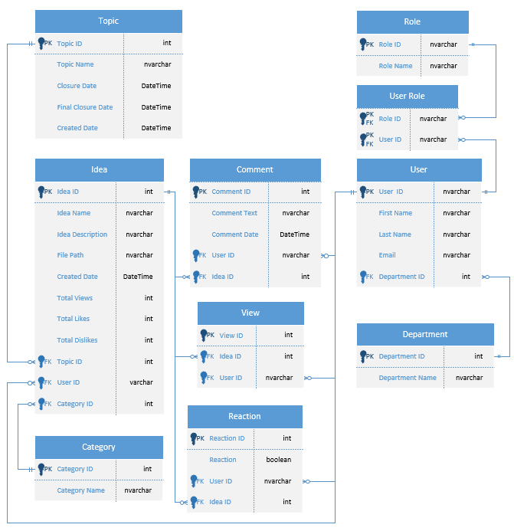

Figure 4. Database Design - Entity Relationship Diagram

We used the User and Role from ASP.Net, so the relationship between User – Role is many - many, so the User Role table will be created to store two primary keys from User and Role. One user can have only one department but one department can have many users, therefore the relationship between User – Department will be one – many. For comments, a comment can be posted by one user, vice versa one user can post many comments so they have relationship one – many between User – Comment. Comment still has one relationship left with Idea, an idea can have many comments but a comment can only belong to one idea, the suitable relationship is one – many. As The Comment, one User or Idea can have many Views but View cannot, so the relationship between View – User and View – Idea will be one – many, too. The relationships between Reaction and User or Reaction and Idea are similar to the View table above, both are one – many. And last but least Idea, we will have 3 relationships for User, Category, and Topic. The relationship for Idea - Category, Idea - Topic, and Idea - User will be one – many because Topic, Category, or User can have many Ideas but an Idea can have only one Category, Topic, and User who posted that idea.

**2.2. Relational Schema.**

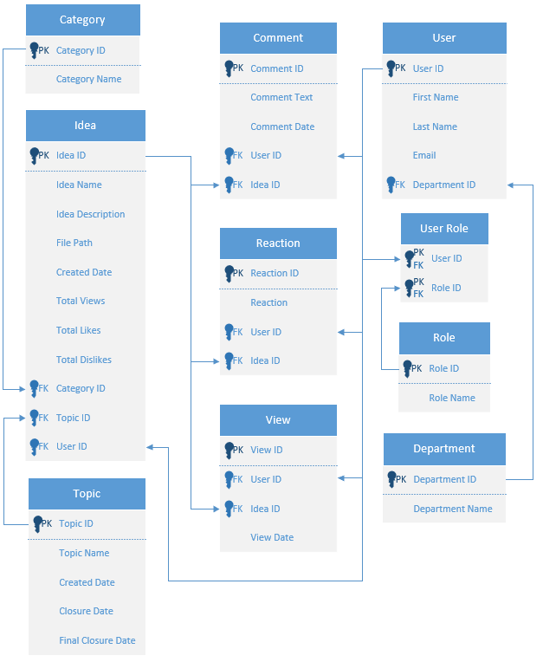

Figure 5. Database Design - Relational Schema

## **3. Functionality Diagram.**

**3.1. Use Case.**

In our project, we separate user role into Admin, QA/QC Coordinator, and Staff. With Admin, we set as the most powerful user who can enrol all function of website. The QA/QC Coordinator will be block at some functions and the Staff is only access to create idea and function relevant to idea. Below here is the use case of three roles in our project.

#### **3.1.1. Use Case - Admin.**

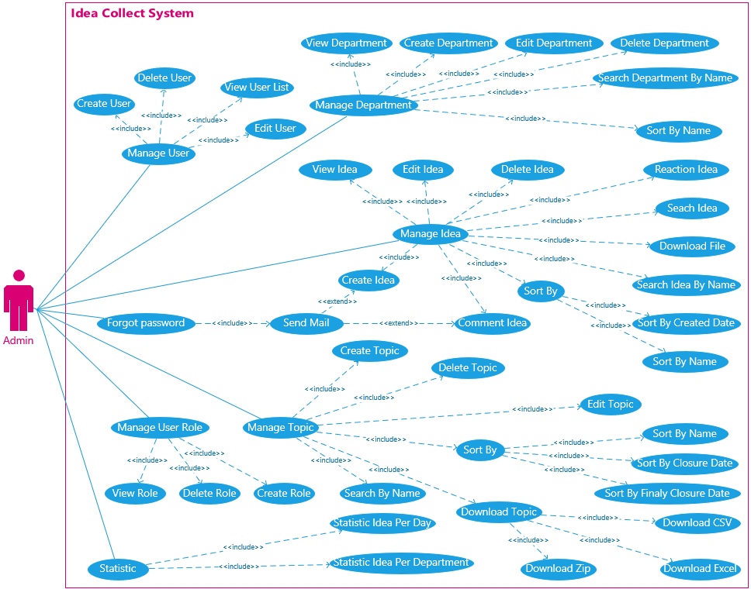

Figure 6. Use Case for Admin

#### **3.1.2. Use Case - QA/QC Coordinator.**

Figure 7. Use Case of QA/QC Coordinator

#### **3.1.3. Use Case - Staff.**

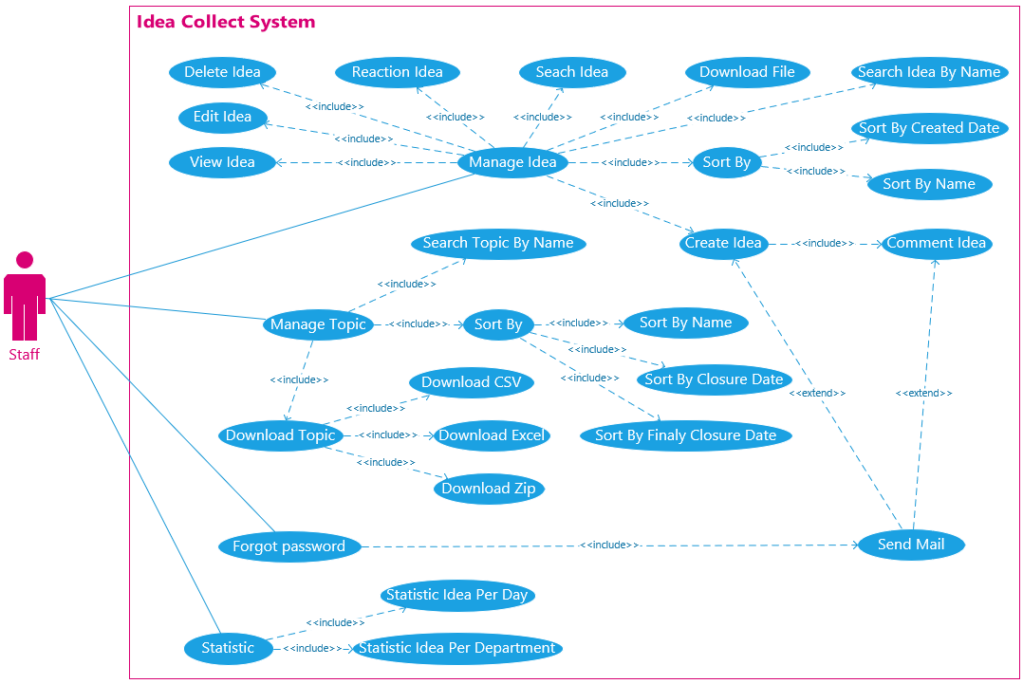

Figure 8. Use Case for Staff

**3.2. Activity Diagram.**

#### **3.2.1. Staff View Most Viewed Ideas.**

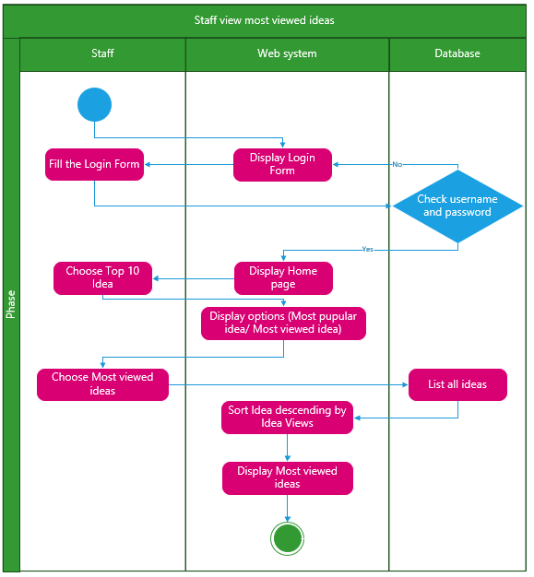

Figure 9. Activity Diagram - Staff view most viewed Ideas

#### **3.2.2. Staff View Most Popular Ideas.**

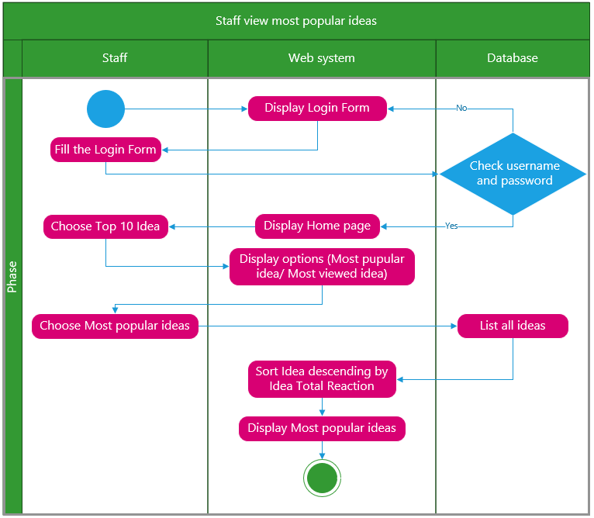

Figure 10. Activity Diagram - Staff view most popular Ideas

#### **3.2.3. Staff Submit Idea.**

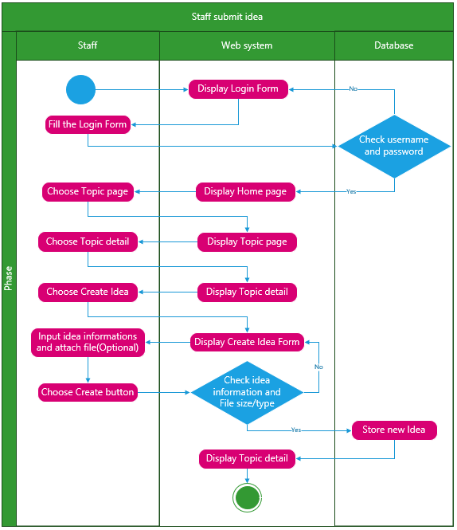

Figure 11. Activity Diagram - Staff submit idea

#### **3.2.4. Staff Edit Idea.**

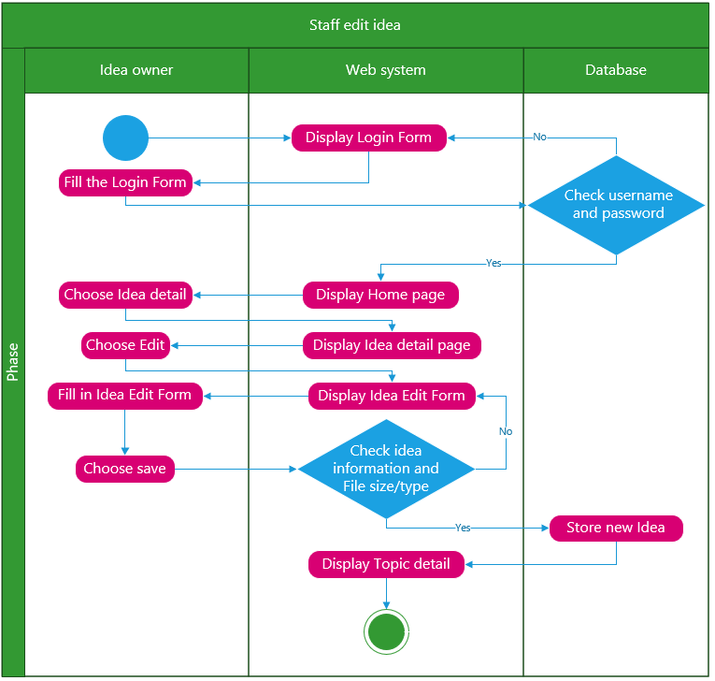

Figure 12. Activity Diagram - Staff edit idea

#### **3.2.5. Staff Delete Idea.**

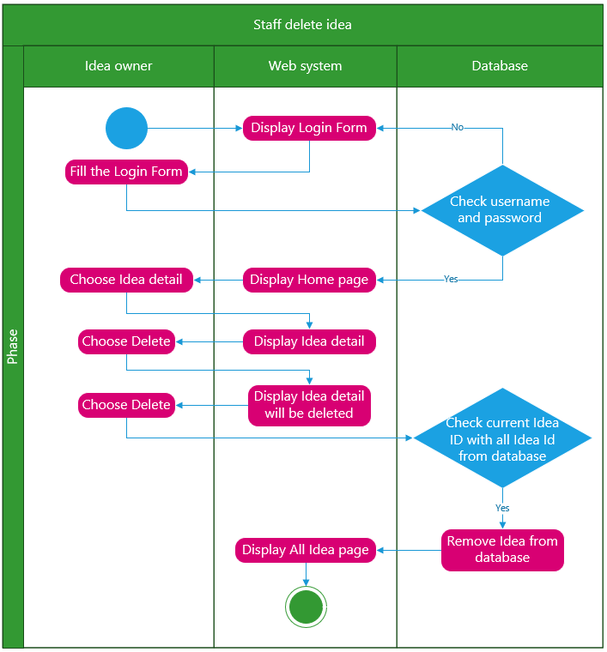

Figure 13. Activity Diagram - Staff delete Idea

#### **3.2.6. Staff Post New Comment in Idea.**

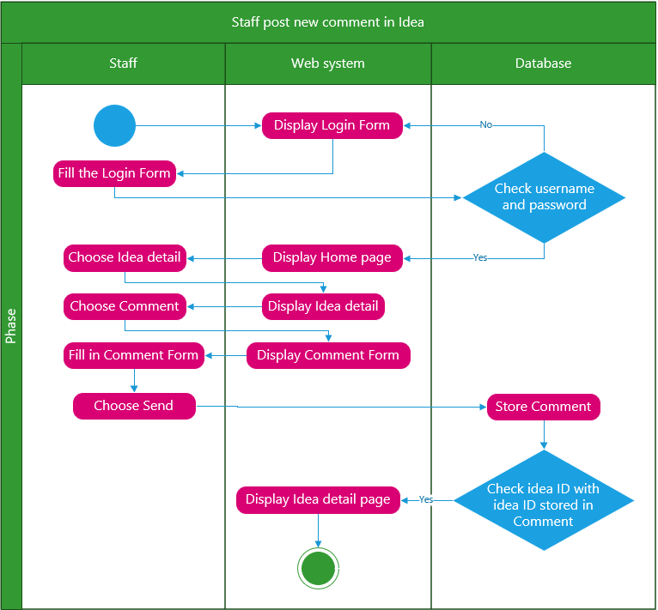

Figure 14. Activity Diagram - Staff post new comment in Idea

#### **3.2.7. Staff Delete Comment in Idea.**

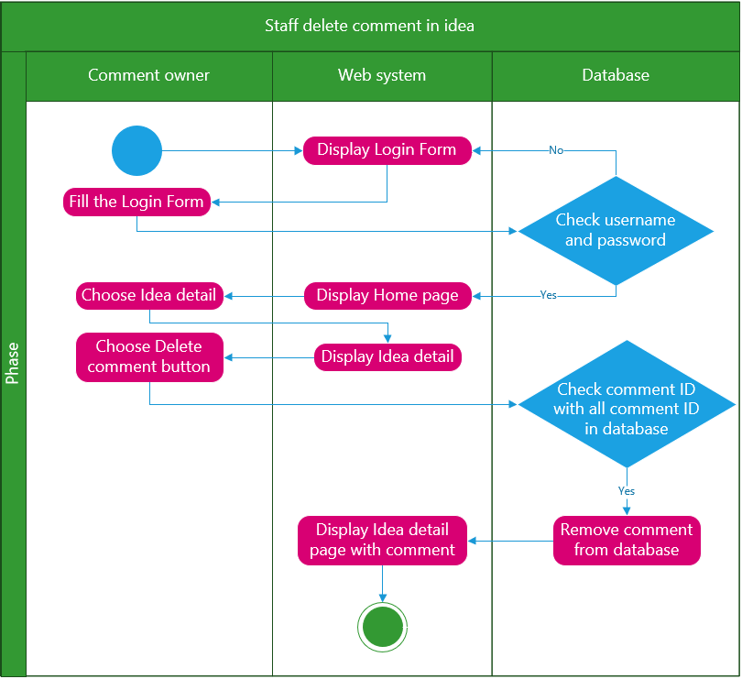

Figure 15. Activity Diagram - Staff delete comment in Idea

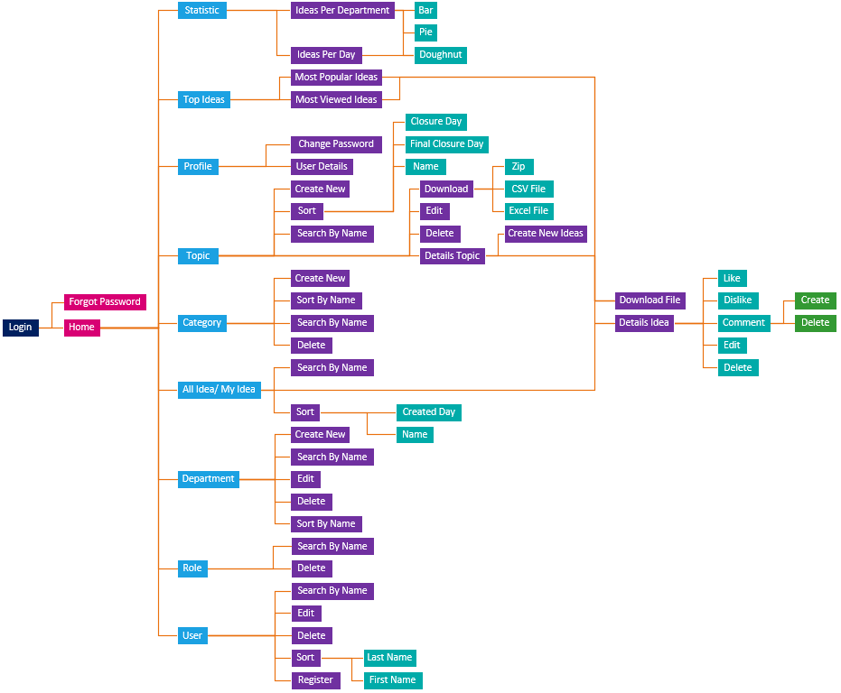**3.3. Sitemap.**

Figure 16. Sitemap

## **4. Project Design.**

## **5. Project Test.**

**5.1. Testing Plan.**

The test plan table including Test Area, Functionality/Area, Description, Expected result and actual result. The table has 8 areas: System, Idea, User List, Category, Department, Topic, Statistic Idea. The test plan involve testing functionality and action in each area to see if the actual result meet the expected result. Below is the table of area and functionality that needed to be tested.

|  |  |  |  |  |
| --- | --- | --- | --- | --- |
| **Test Area** | **Function/Action** | **Description** | **Expected result** | **Result** |
| System | Login | Login with email and password which is registered | Successful login | Pass |
| System | Role based access | Account has different access based on their role | Site show different function and content base on their role | Pass |
| System | Send mail recovery | User email will receive mail for reset account password | Successful receive mail after submit idea | Pass |
| Idea | Display idea list from database | View the idea list table including Idea name, description, file path, created date. | Output table of ideas which are summited by the current account | Pass |
| Idea | Search idea name | Enter idea name that needed to find | Output the correct idea | Pass |
| Idea | Sorting idea | Sort idea based on idea name’s first letter and create date | Sorted idea list | Pass |
| Idea | Download idea file | Click the download button to download file from the idea that has file path | The file is download to the current device | Pass |
| Idea | Like and dislike idea | Click like or dislike button and the system will save the total react to the idea | Show the total like and dislike of the idea | Pass |
| Idea | Comment to idea | Click comment button and input your comment about the idea and it will be posted anonymously | The comment posted | Pass |
| Idea | Send mail after submitting idea | User email will receive mail after submitting idea on system | Successful receive mail after submit idea | Pass |
| Idea | Send mail after receive comment | User email will receive mail after receive comment on web app | Successful receive mail after receive comment | Pass |
| Idea | Count view idea | Count every account has view the idea detail | Save total view of all account | Pass |
| Idea | Edit idea | Change the idea details | Change to new detail | Pass |
| Idea | Delete idea | Delete the idea | The idea removed from the list | Pass |
| Idea | Submit idea | Input idea name, description, category id and file attach | The idea is submitted and save to the database system | Pass |
| User List | Search user name | Enter user name that needed to find | Output the correct user | Pass |
| User List | Sorting user first name | Sort user based on user first name’ first letter | Sorted user list | Pass |
| User List | Sorting user first name | Sort user based on user first name’ first letter | Sorted user list | Pass |
| User List | Sorting user last name | Sort user based on user last name’ first letter | Sorted user list | Pass |
| User List | Sorting user department | Sort user based on user department’s first letter | Sorted user list | Pass |
| User List | Create user | Input name, email, department, password and role for new user | New user is created and able to login to the system | Pass |
| User List | Edit user | Edit the information of the user | New user detail is set | Pass |
| User List | Delete user | Delete user from the system | Cannot login with deleted user | Pass |
| Role list | Create role | Create a new role for user account | Successful create new role | Pass |
| Role list | Delete role | Delete a role from system | Successful delete role | Pass |
| Category | Search category | Enter category that needed to find | Output the correct category | Pass |
| Category | Sorting category | Sort category based on category’ first letter | Sorted category | Pass |
| Category | Create category | Create a category for idea | Successful create new category | Pass |
| Category | Edit category | Edit the category | New category is set | Pass |
| Category | Delete category | Delete category from the system | Successful delete category | Pass |
| Department | Sorting department | Sort department based on department name’s first letter | Sorted department | Pass |
| Department | Create department | Create a department | Successful create new department | Pass |
| Department | Edit department | Edit the department | New department is set | Pass |
| Department | Delete department | Delete department from the system | Successful delete department | Pass |
| Topic | Search topic | Enter topic that needed to find | Output the correct topic | Pass |
| Topic | Sorting topic name | Sort topic based on topic name’s first letter | Sorted topic | Pass |
| Topic | Sorting topic closure date | Sort topic based on topic closure date | Sorted topic | Pass |
| Topic | Sorting topic final closure date | Sort topic based on topic final closure date | Sorted topic | Pass |
| Topic | Create topic | Create a new topic | Successful create new topic | Pass |
| Topic | Edit department | Edit the topic | New topic is set | Pass |
| Topic | Delete topic | Delete topic from the system | Successful delete topic | Pass |
| Topic | Download topic file | Download CSV, Excel and Zip topic file | Successful download file | Pass |
| Statistic Idea | Statistic idea pre department | Output idea density of different department via bar chart, pie chart, doughnut chart | Show chart density | Pass |
| Statistic Idea | Statistic idea per day | Output idea density of days via bar chart, pie chart, doughnut chart | Show chart density | Pass |
| Statistic Idea | Output most popular idea | Select and show out for the user the idea with most reaction | Output the most popular idea | Pass |
| Statistic Idea | Output most view idea | Select and show out for the user the idea with most view | Output the most view idea | Pass |

Table 2. Testing Plan

**5.2. Test Log.**

Test log provides information related to different test operations that include a source of issues and reasons for the failed operation. Because our team is using Agile method for holding project, we separate the test log into three sprints as below:

**5.*2*.1. Test Log – Sprint 1.**

|  |  |  |  |  |  |
| --- | --- | --- | --- | --- | --- |
| **Sprint 1** | | | | | |
| ***NO*** | ***User Story*** | ***Function*** | ***Description*** | ***Time*** | ***Status*** |
| 1 | As an admin, I want to CRUD topic so that I can create topic for user add ideas. | CRUD topic for admin | Test create, update, delete topic | 12/03/2023 | Pass |
| 2 | As an admin, I need to log in, log out and set the role identity for all user that decentralize functions in system. | Login, logout | Login with the given account and logout | 12/03/2023 | Pass |
| 3 | As an admin or a QA/QC coordinator, I want to CRUD category that I can know the cover area of the ideas uploaded by users. | CRUD category as admin and QA/QC coordinator account | Test create, update, delete category | 12/03/2023 | Pass |
| 4 | As an user, I want to paginate the idea list page, sort and search idea that I can find the need idea | Paginate the idea list page, sort and search idea | Paginate the idea list page, sort and search idea | 12/03/2023 | Pass |
| 5 | As an admin or a QA/QC coordinator, I want to CRUD department that I can specific user's department. | CRUD department as an admin or a QA/QC coordinator | Test create, update, delete department | 12/03/2023 | Pass |

Table 3. Test Log - Sprint 1

#### **5.2.2. Test Log – Sprint 2.**

|  |  |  |  |  |  |
| --- | --- | --- | --- | --- | --- |
| **Sprint 2** | | | | | |
| ***NO*** | ***User Story*** | ***Function*** | ***Description*** | ***Time*** | ***Status*** |
| 1 | As a user, I want to CRUD Idea anonymously in the topic that I'm interested so that anybody can discuss. | Submit idea anonymously | User submit idea for anybody to view and discuss | 26/03/2023 | Pass |
| 2 | As an user, I want to change password when I forgot. | Change password | User can change password when they forgot | 26/03/2023 | Pass |
| 3 | As an user, I want to reaction function for voting so that I can judge the idea details. | React function | Click like or dislike button and the system will save the total react to the idea | 26/03/2023 | Pass |
| 4 | As an admin, I need to close the submit on date so that forbid user stop submitting new idea. | Submit expired block | close the submit on date so that forbid user stop submitting new idea | 26/03/2023 | Pass |
| 5 | As an admin, I need to close the comment and reactions on date so that forbid the user from comment and react | Block comment, reactions | Block comment, reactions on final closure date | 26/03/2023 | Pass |
| 6 | As an user, I need to export topic as excel, csv file so that I can read all simple information about the topic. | Export topic as excel, csv file | Change all ideas information in one topic into CSV (Comma-separated values) format.  Change all ideas information in one topic into Excel file. | 26/03/2023 | Pass |
| 7 | As an user, I need to download idea file or topic files by archive them to RAR so that I can read the relevant documentation. | Download idea/topic file | Download file of every single idea.  Download file of all ideas of the topic. | 26/03/2023 | Pass |
| 8 | As an user, I want to CRUD comment so that I can discuss with anybody about the idea I'm interested. | Comment | Comment about the idea for everyone to see | 26/03/2023 | Pass |

Table 4. Test Log - Sprint 2

#### **5.2.3. Test Log – Sprint 3.**

|  |  |  |  |  |  |
| --- | --- | --- | --- | --- | --- |
| **Sprint 3** | | | | | |
| ***NO*** | ***User Story*** | ***Function*** | ***Description*** | ***Time*** | ***Status*** |
| 1 | As an user, I want to have most views and like list to know which idea is most considered by users. | Most views and like list | Most views and like list to know which idea is most considered by users | 09/04/2023 | Pass |
| 2 | As an user, I need to show all my account information that I can know all my saved details. | View account information | Show all current account information | 09/04/2023 | Pass |
| 3 | As an user, I want to be displayed all function that fit to my role and my account so that can't conflict role duty in the system. | Set authorize based on account’s role | Only staff can view, comment, react, and upload idea. Any anonymous must login to use functions.  Classify functions within three roles: Admin, QA/QC Manager, Staff.  The function create/read/update/delete (CRUD) must be modified follow every user/account. | 09/04/2023 | Pass |
| 4 | As an Coordinator and an admin, I need a statistic charts so that we can make the decision based on the data. | Statistic charts | Show statistic charts so that coordinator and admin can make the decision based on the data | 09/04/2023 | Pass |
| 5 | As an admin, I need to CRUD users that have in database so that I can manage users. | CRUD users | CRUD users that have in database so that admin can manage users. | 09/04/2023 | Pass |
| 6 | As user, I want to use the website in multiple operation and devices so that cover all user's devices. | Responsive layout | The frontend of the website will change depend on which device the user is using | 09/04/2023 | Pass |
| 7 | As user, I need to search and sort in every table in the system so that I can find necessary | Sort table | Sort table | 09/04/2023 | Pass |

Table 5. Test Log - Sprint 3

**5.3. Test Data.**

#### **5.3.1. User Register.**

|  |  |  |  |  |  |  |  |
| --- | --- | --- | --- | --- | --- | --- | --- |
| **First Name** | **Last Name** | **Email** | **Department** | **Password** | **Confirm Password** | **Role** | **Output** |
| John | Joe | [J@gmail.com](mailto:J@gmail.com) | Null | Jjoe123@ | Jjoe123@ | Null | The Role field is required.  The Department field is required. |
| 123 | 456 | [123@gmail.com](mailto:123@gmail.com) | Marketing | Null | Null | Staff | The Password field is required. |
| 123 | 456 | [123@gmail.com](mailto:123@gmail.com) | Marketing | 123 | 456 | Staff | The Password must be at least 6 and at max 100 characters long.  The password and confirmation password do not match. |
| Hoang | Nguyen | null | Business | Hoang123.. | Hoang123.. | QA/QC Coordinator | The Email field is required. |
| Null | Null | dangdat@@ | Marketing | datN123#@ | datN123#@ | Staff | The First Name field is required.  The Last Name field is required.  The Email field is not a valid email address. |

Table 6. Test Data – User Register

#### **5.3.2. Create Idea.**

|  |  |  |  |  |  |
| --- | --- | --- | --- | --- | --- |
| **Idea** | **Idea Description** | **Category** | **Attach File** | **Term Conditions Agreement** | **Output** |
| giao duc gioi tinh | Asds#@! | Web | Dự án 2 - Giáo dục giới tính.pptx | Checked | Success |
| Text*50 | Supportive | Web | Null | Checked | Success |
| Null | Null | Null | Null | Null | The Idea Name field is required.  The Idea Description field is required.  The Category Id field is required.  Please accept Term & Condition. |

Table 7. Test Data - Create Idea

**5.3. Testing Evidence.**

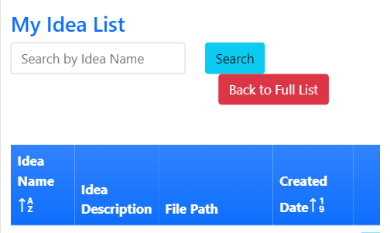 While testing responsive for mobile device, we found a bug on My Idea List page. The bug is that the search input bar and buttons are not change due to the width of mobile device which lead to the below image result.

Figure 17. Responsive bug on My Idea List

After finding the bug we had fixed to meet the first design of the website. We fixed it by rearrange button “Back to Full List” stay the same line as button “Search” but in the phone, the space for inputting Idea Name is cover full width of the line, so we decide to setting two buttons stays at the next line.

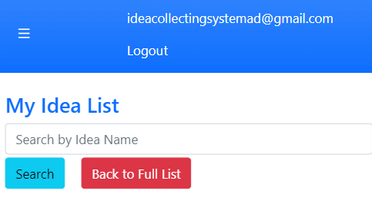

Figure 18. Fix responsive bug on My Idea List

## **6. Agile Method.**

**6.1. Product Backlogs.**

|  |  |  |  |  |  |  |
| --- | --- | --- | --- | --- | --- | --- |
| **NO** | **As a/an…** | **I want to be able to…** | **So that…** | **Priority** | **Sprint** | **Status** |
| 1 | Administrator | Create, Read, Update, and Delete topic | I can manage the topics | Must | 1 | Done |
| 2 | Administrator | Log in, log out, and appoint the roles for all users | Users will be able to carry out functions according to their roles | Must | 1 | Done |
| 3 | User | Received confirmation mail from the system | I am aware that my idea has been successfully created | Must | 1 | Done |
| 4 | Administrator | Create, Read, Update, and Delete department | I can manage the departments in the system in a way that it will be identical to the departments that the university has | Must | 1 | Done |
| 5 | QA Coordinator | Create, Read, Update, and Delete department | I can manage the departments in the system in a way that it will be identical to the departments that the University has | Must | 1 | Done |
| 6 | Administrator | Create, Read, Update, and Delete category | I can manage the categories that the ideas fall under | Must | 1 | Done |
| 7 | QA Coordinator | Create, Read, Update, and Delete category | I can manage the categories that the ideas fall under | Must | 1 | Done |
| 8 | User | Paginate the list of ideas, Sort, and Search for ideas | I can make the list page more organized and easily search for the ideas I specifically want to look at | Must | 1 | Done |
| 9 | User | CRUD my idea anonymously in the relevant topic | I can remain private and discuss about certain ideas | Must | 2 | Done |
| 10 | User | Change password | I can recover my account if I forgot my password | Should | 2 | Done |
| 11 | User | React to the ideas posted | I can show my approval or disapproval of the ideas | Must | 2 | Done |
| 12 | Administrator | Close the submission date for topics | I can forbid users from submitting new ideas | Should | 2 | Done |
| 13 | User | Export the topics into excel and csv files | I can compile all the topics and share it with other people who might be interested | Should | 2 | Done |
| 14 | User | Download the topics or specific idea as a RAR format | I can read and share the topics and ideas under a different format | Should | 2 | Done |
| 15 | User | Create, Read, Update, and Delete comment | I can discuss more about the ideas with other users | Should | 2 | Done |
| 16 | User | Check and see how many views does an idea have | I can be informed of how many views does an idea have | Should | 2 | Done |
| 17 | User | Have a list of the most viewed and popular ideas | I can be aware of the ideas that are controversial or popular | Should | 3 | Done |
| 18 | User | Have a page that shows all of my account information | I can acknowledge whether my account has the correct information about me | Could | 3 | Done |
| 19 | User | View a list of functions that my role can perform | I can correctly fulfill the responsibilities related to my roles in the system | Should | 3 | Done |
| 20 | Administrator | Create, Read, Update, and Delete the users of the system | I can manage the users | Should | 3 | Done |
| 21 | Administrator | Have access to statistical charts | I can make strategic decision based on the data available | Could | 3 | Done |
| 22 | QA Coordinator | Have access to statistical charts | I can make strategic decision based on the data available | Could | 3 | Done |
| 23 | User | Have access to the website on different operating systems and devices | I can use the website across all my devices | Should | 3 | Done |
| 24 | User | Search and sort every table in the system | I can quickly find the vital information | Could | 3 | Done |

Table 8. Product Backlog

**6.2. Sprint Backlogs.**

#### **6.2.1. Sprint 1.**

|  |  |  |  |  |  |  |  |
| --- | --- | --- | --- | --- | --- | --- | --- |
| **NO** | **User Story** | **Task** | **Owner** | **Priority** | **Status** | **Start date** | **End date** |
| 1 | As an admin, I want to CRUD topics so that I can create topics for users to add ideas. | Back-end: Create functions CRUD Topic. | Vinh | Must | Done | 15/02/2023 | 17/02/2023 |
| Front-end: Decorate the design, color, button for functions and topic list. | Khoa, Quan | Must | Done |
| 2 | As an admin, I need to log in, log out and set the role identity for all users that decentralize functions in the system. | Back-end: Create add role function. | Long | Must | Done | 15/02/2023 | 18/02/2023 |
| Back-end: Add role to register page. | Long | Must | Done |
| Front-end: Decorate the design, color, button for setting role function and role list. | Khoa, Quan | Must | Done |
| Front-end: Design login and register view page. | Khoa, Quan | Must | Done |
| 3 | As a user, I want the system to send me a confirming email after submitting an idea so that I can know whether the idea was created successfully or not. | Back-end: Install MailKit package | Luan | Must | Done | 15/02/2023 | 19/02/2023 |
| Back-end: Create Send Mail function for Create Idea | Luan | Must | Done |
| 4 | As an admin or a QA/QC coordinator, I want to CRUD department so that I can specify the user's department. | Back-end: Create CRUD department functions. | Luan | Must | Done | 17/02/2023 | 19/02/2023 |
| Front-end: Decorate the design, color, button for functions and department list. | Khoa | Must | Done |
| 5 | As an admin or a QA/QC coordinator, I want to CRUD category so that I can know the coverage area of the ideas uploaded by users. | Back-end: Create CRUD category functions. | Luan | Must | Done | 20/02/2023 | 22/02/2023 |
| Front-end: Decorate the design, color, button for functions and topic list. | Khoa | Must | Done |
| 6 | As a user, I want to paginate the idea list page, sort and search ideas so that I can find the needed idea | Back-end: Pagination max 5 ideas per page. | Long | Should | Done | 23/02/2023 | 25/02/2023 |
| Back-end: Sort by the upload date of the idea from latest to oldest as default. | Long | Should | Done |
| Back-end: Searching idea by idea name. | Long | Should | Done |
| Front-end: Decorate the design, color, button for linking idea function and idealist. | Khoa | Should | Done |

Table 9. Sprint Backlogs - Sprint 1

#### **6.2.2. Sprint 2.**

|  |  |  |  |  |  |  |  |
| --- | --- | --- | --- | --- | --- | --- | --- |
| **NO** | **User Story** | **Task** | **Owner** | **Priority** | **Status** | **Start date** | **End date** |
| 1 | As a user, I want to CRUD Ideas anonymously on the topic that I'm interested in so that anybody can discuss them. | Back-end: Create basic CRUD idea function | Long | Must | Done | 27/02/2023 | 01/03/2023 |
| Back-end: Create upload file function. | Long | Must | Done |
| Back-end: Must accept Terms and Conditions for submit idea. | Luan | Must | Done |
| Back-end: Category of idea set as dropdown list. | Long | Must | Done |
| Back-end: Assign topic Id to Idea automatically. | Luan | Must | Done |
| Front-end: Decorate the design, color, button for submit idea function and idealist. | Khoa | Must | Done |
| 2 | As a user, I want to change my password when I forgot. | Back-end: Send an email have the link to change account’s password. | Luan | Must | Done | 27/02/2023 | 01/03/2023 |
| Front-end: Decorate Forgot password page | Quan | Must | Done |
| 3 | As a user, I want to reaction function for voting so that I can judge the idea details. | Back-end: Like/Dislike for each idea function | Luan, Vinh | Should | Done | 02/03/2023 | 04/03/2023 |
| Back-end: Count number of Like/Dislike | Luan, Vinh | Should | Done |
| 4 | As an admin, I need to close the submit on the date so that forbids users to stop submitting new ideas. | Back-end: Set condition to lock submitting idea on closure date | Long | Should | Done | 04/03/2023 | 05/03/2023 |
| Back-end: Set condition to lock Comment/ Reaction/ Count View on final closure date | Long | Should | Done |
| 5 | As a user, I want to CRUD comment so that I can discuss with anybody the idea I'm interested in. | Back-end: Create CRUD comment function. | Luan, Vinh | Should | Done | 06/03/2023 | 08/03/2023 |
| Back-end: Send mail to idea’s owner when his or her ideas | Luan, Vinh | Should | Done |
| Back-end: Sort comment by descending as default to see latest comments | Long | Could | Done |
| Front-end: Decorate comment list of every idea. | Khoa | Should | Done |
| Front-end: Set add comment function at the same page with idea detail and comment list. | Khoa | Should | Done |
| 6 | As a user, I need to export topics as Excel, or CSV files so that I can read all simple information about the topic. | Back-end: Install ClosedXML package | Luan | Should | Done | 04/03/2023 | 08/03/2023 |
| Back-end: Change all idea information in topic into CSV file and download. | Luan | Should | Done |
| Back-end: Change all idea information in topic into Excel file and download. | Luan | Should | Done |
| 7 | As a user, I need to download idea files or topic files by archiving them to RAR so that I can read the relevant documentation. | Back-end: Install SharpZipLib.NETStandard | Long | Should | Done | 06/03/2023 | 09/03/2023 |
| Back-end: Create list of all files of each idea in a topic | Luan | Should | Done |
| Back-end: Zip all files from list of all files then download zip | Long | Should | Done |
| Back-end: Zip file from idea then download zip | Long | Should | Done |
| 8 | As a user, I want to check the idea's view so that I can know how many people have seen my idea | Back-end: Set condition to save a view with user ID | Long | Should | Done | 08/03/2023 | 10/03/2023 |
| Back-end: Count number of views of an idea | Long | Should | Done |

Table 10. Sprint Backlogs - Sprint 2

#### **6.2.3. Sprint 3.**

|  |  |  |  |  |  |  |  |
| --- | --- | --- | --- | --- | --- | --- | --- |
| **NO** | **User Story** | **Task** | **Owner** | **Priority** | **Status** | **Start date** | **End date** |
| 1 | As a user, I want to have the most views and popular idea list to know which idea is most considered by users. | Back-end: Create the most popular ideas by descending Total Reaction (Like: +1; Dislike: -1) | Long | Should | Done | 13/03/2023 | 15/03/2023 |
| Back-end: Create the most viewed ideas by count all views then sort by descending | Long | Should | Done |
| Front-end: Create 2 pages for Most popular idea list and most viewed idea list | Long | Should | Done |
| 2 | As a user, I need to show all my account information so that I can know all my saved details. | Front-end: Query current user account information then display in profile page | Luan | Could | Done | 13/03/2023 | 15/03/2023 |
| 3 | As an admin, I need to CRUD users that have in the database so that I can manage users. | Back-end: Create CRUD for user management | Long | Should | Done | 16/03/2023 | 19/03/2023 |
| Front-end: Create 4 pages for CRUD user | Long | Should | Done |
| 4 | As a Coordinator and an admin, I need statistical charts so that we can make the decision based on the data. | Back-end: Statistic based on number of ideas created by each department. | Vinh | Could | Done | 16/03/2023 | 21/03/2023 |
| Back-end: Statistic based on number of ideas in a day. | Luan | Could | Done |
| Front-end: Decorate charts, choose chart type button. | Khoa | Could | Done |
| 5 | As a user, I need to search and sort every table in the system so that I can find necessary | Back-end: Add search function for idea, category, department, topic, user. | Long | Could | Done | 21/03/2023 | 23/03/2023 |
| Back-end: Add sort function idea, category, department, topic, user. | Long | Could | Done |
| Front-end: Design and arrange search, sort button, set condition for icon. | Long | Could | Done |
| 6 | As a user, I want to be displayed all functions that fit my role and my account so that can't conflict with role duty in the system. | Back-end: Hosting website on Render.com | Long | Should | Done | 19/03/2023 | 25/03/2023 |
| Back-end: Hosting database on Somee.com | Long | Should | Done |
| Front-end: Do responsive for website. | Khoa | Should | Done |
| 7 | As a user, I want to use the website in multiple operation and devices so that cover all user's devices. | Back-end: Set authorize for suitable functions as current user role and user’s ID. | Long | Should | Done | 13/03/2023 | 25/05/2023 |
| Front-end: Hide button depend on current account’s id and role. | Luan | Should | Done |

Table 11. Sprint Backlogs - Sprint 3

## **10. REFERENCES.**

LIBRE, N. J. J. O. O. E. E. 2021. A Discussion Platform for Enhancing Students Interaction in the Online Education. 12**,** 07-12.